

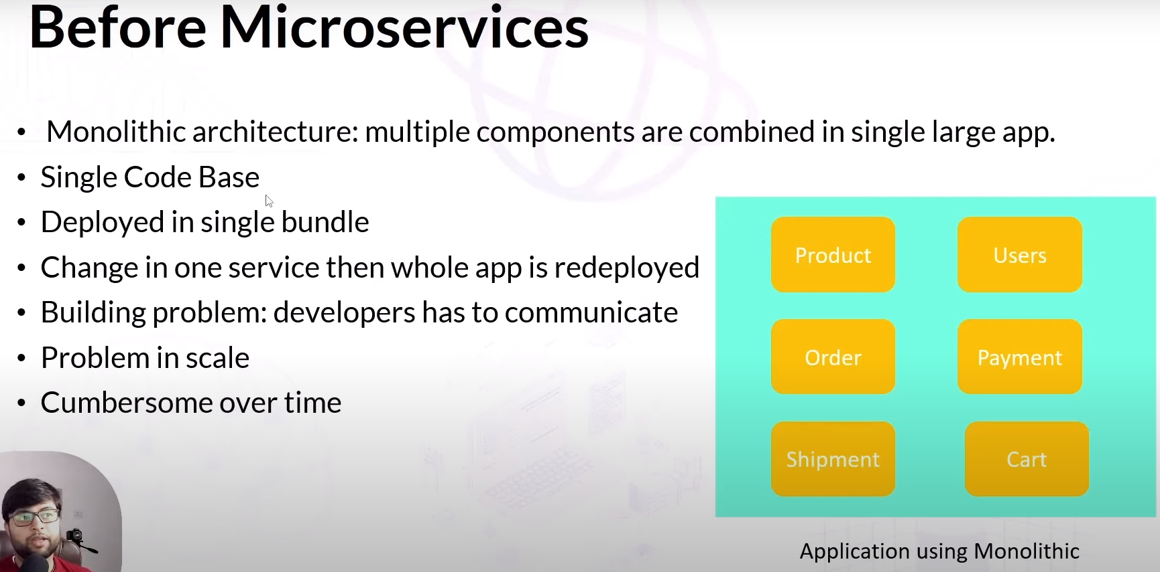

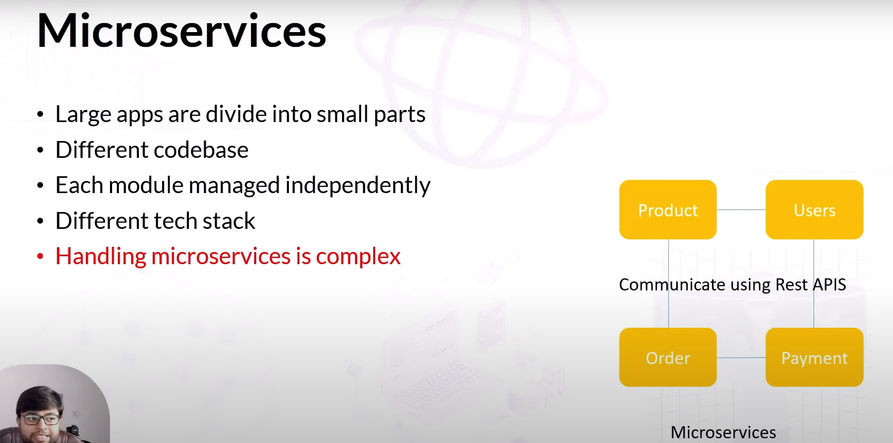

There are many ways to communicate each other of modules. One is Rest Api

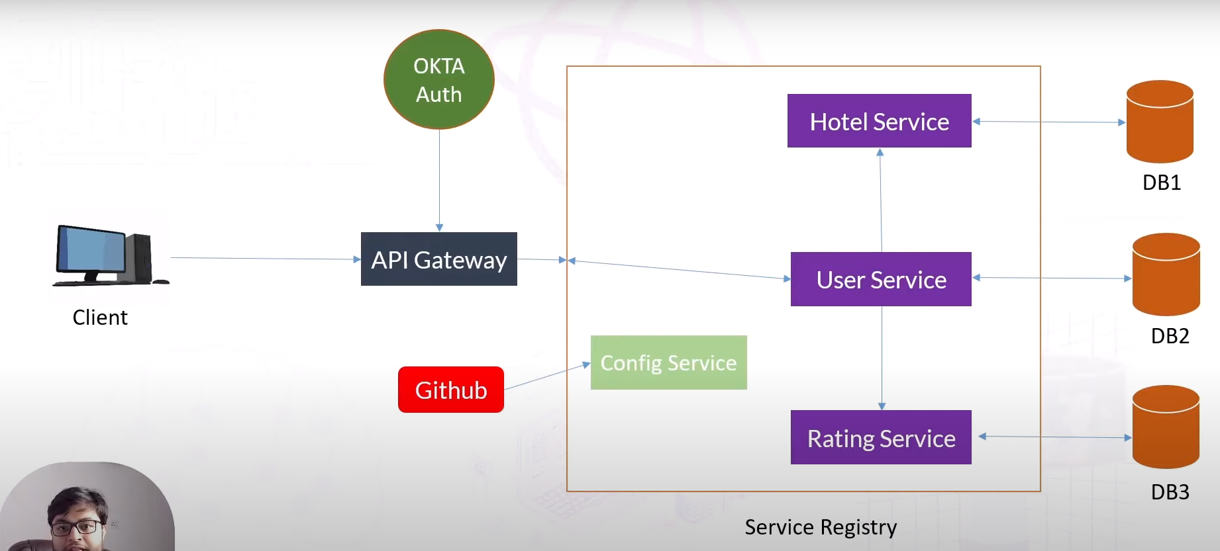

Config Server is used for common configuration of services. We can do this using github.

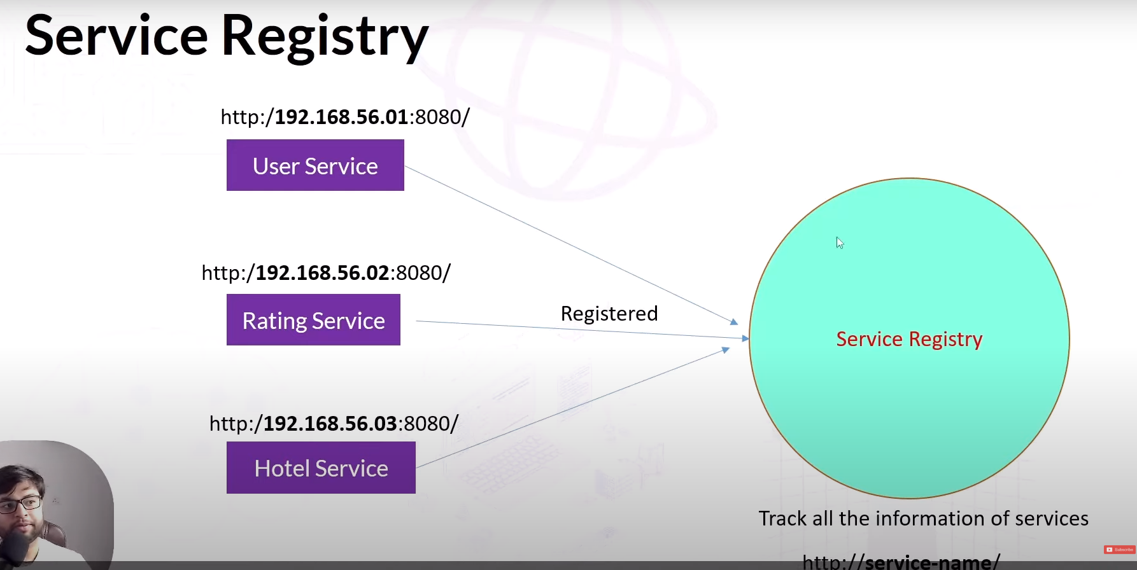

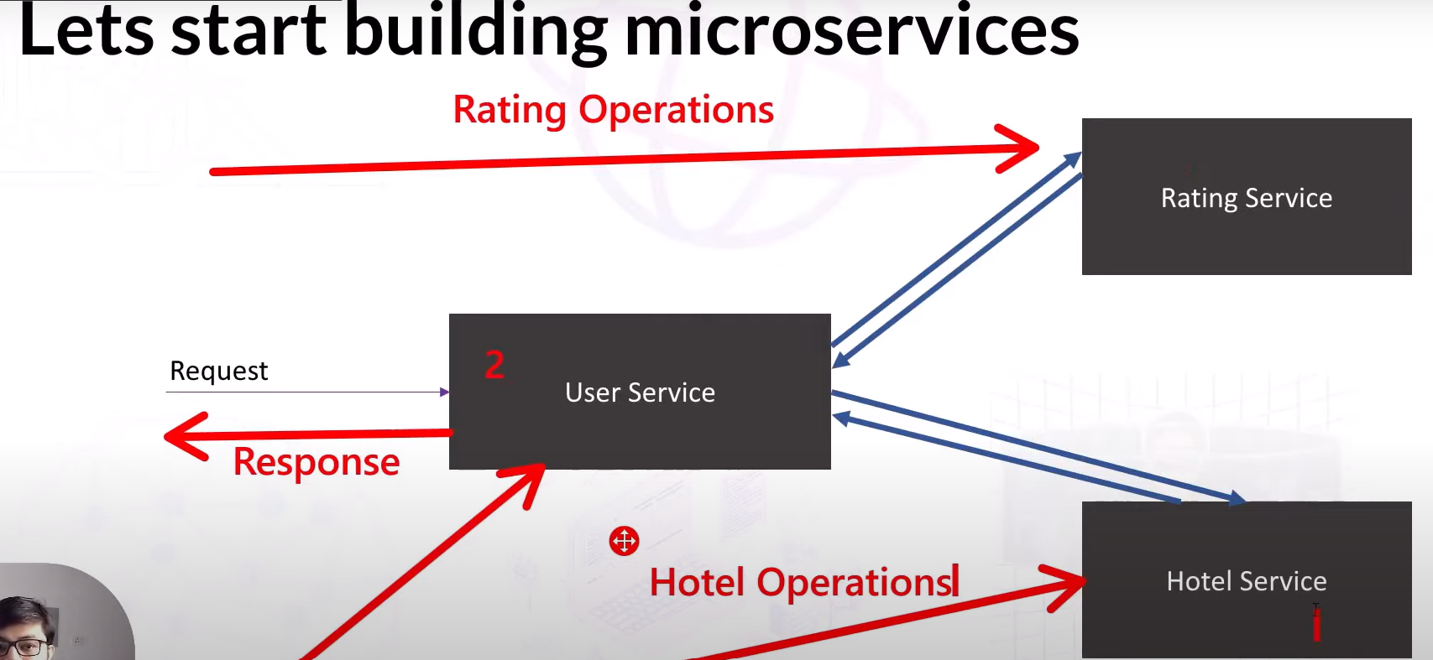

**User Service**

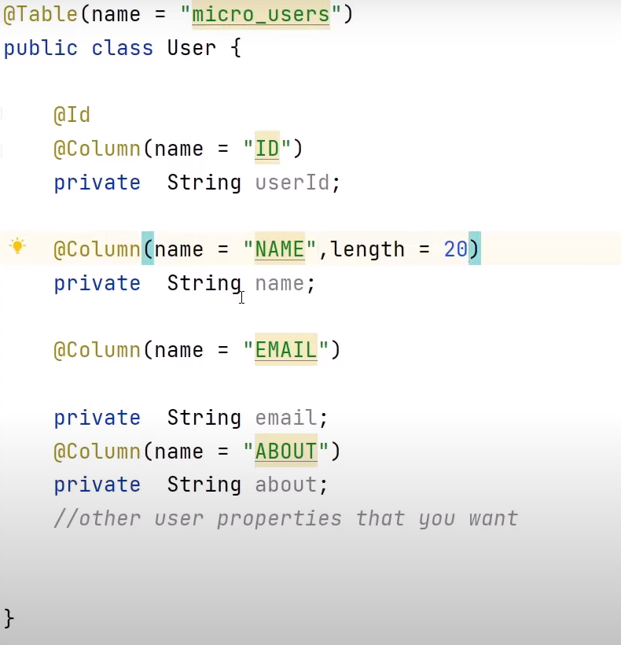

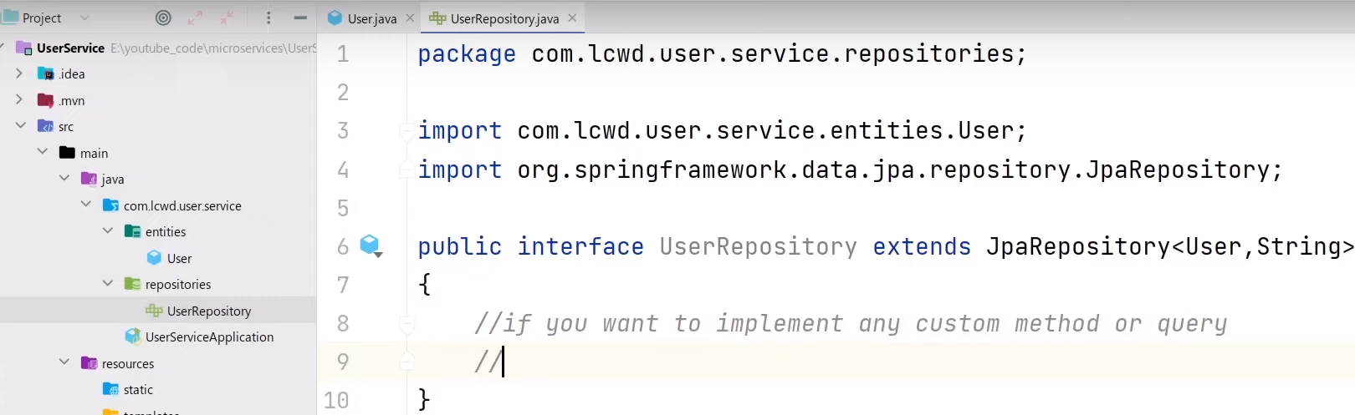

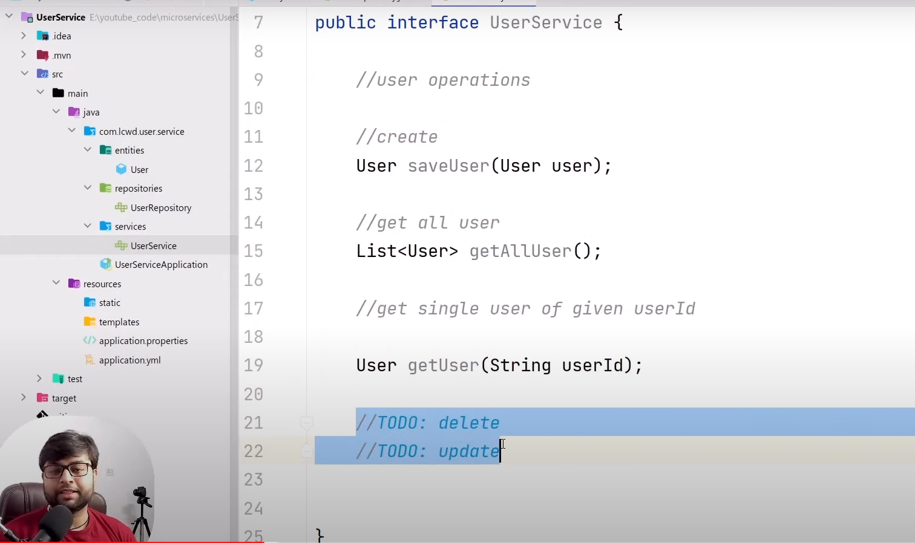

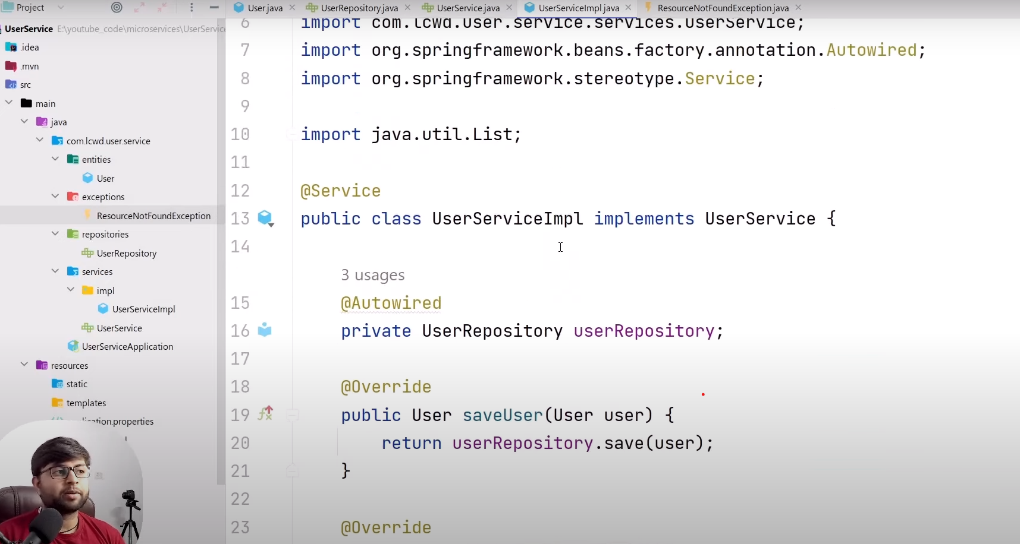

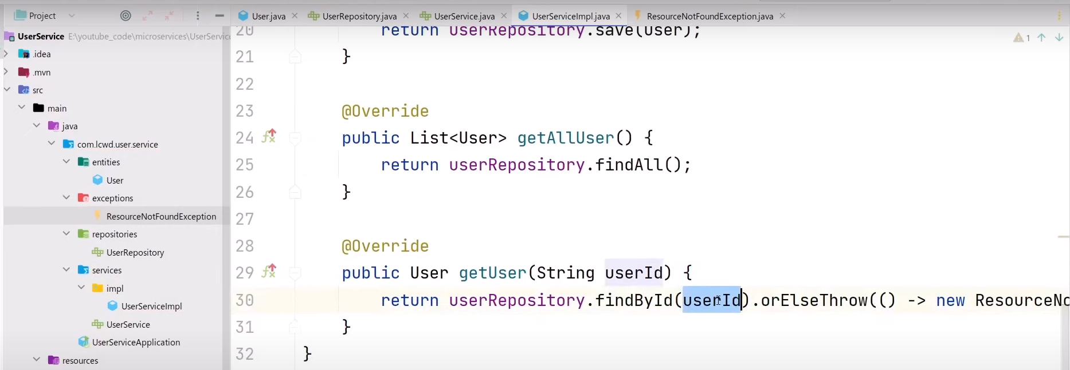

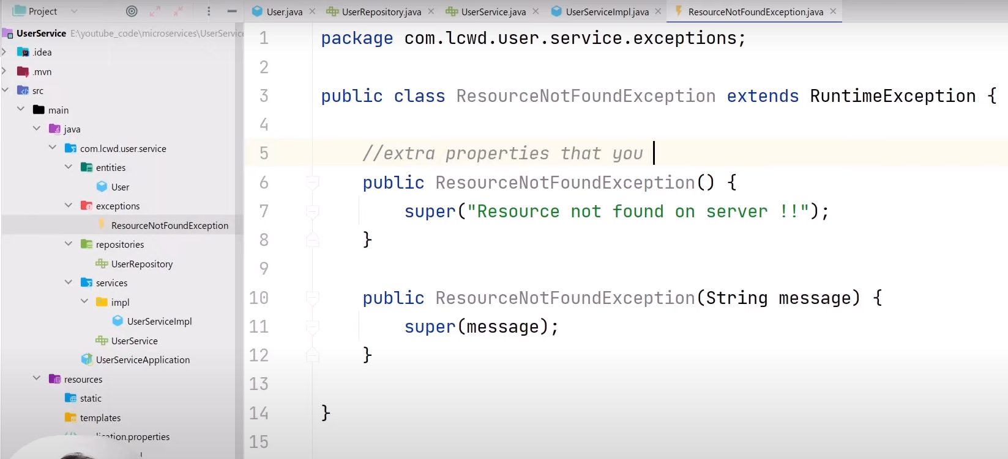

**We can handle exception globally as given below:**

**The annotation @ExceptionHandler is responsible for handling the exception.**

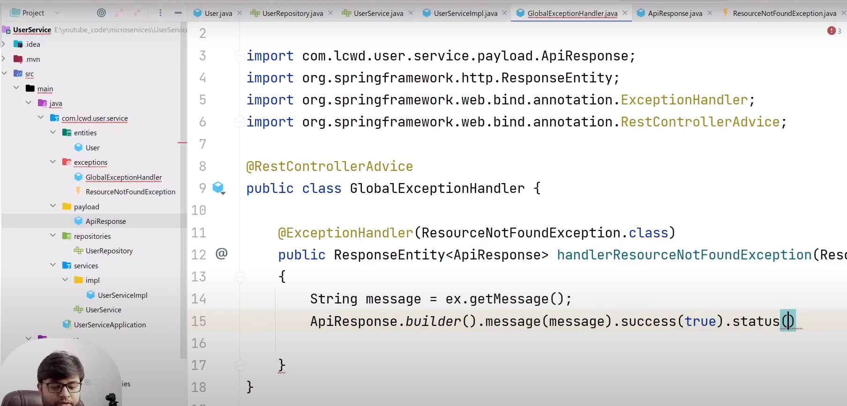

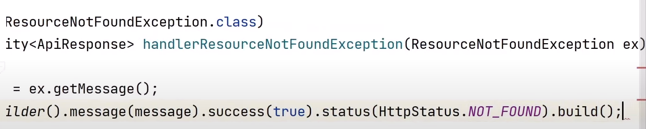

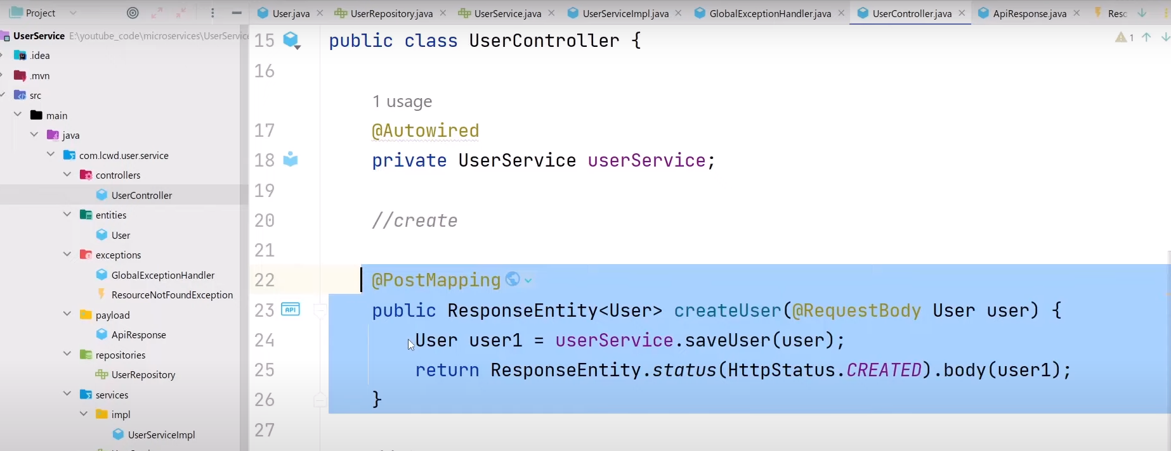

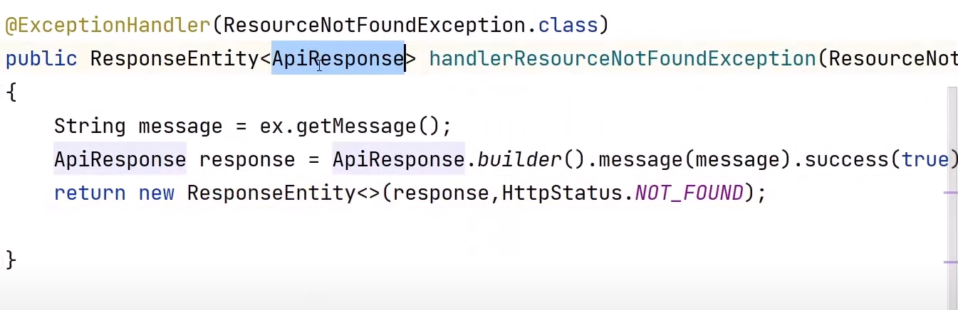

**Note: If you don’t want to set column in database of a table(Entity Class) then use @Transient on the above of data member.**

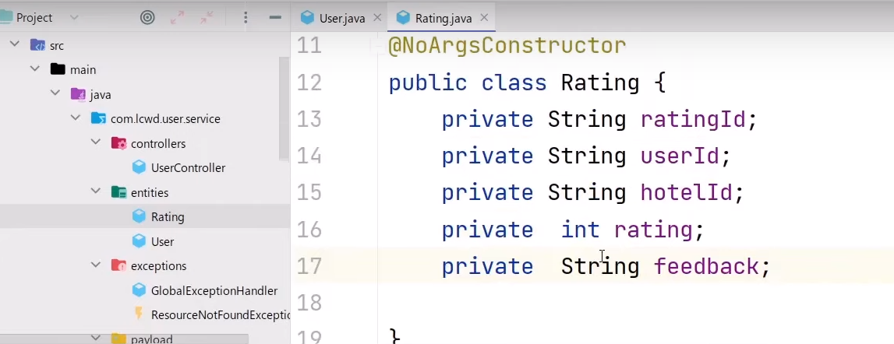

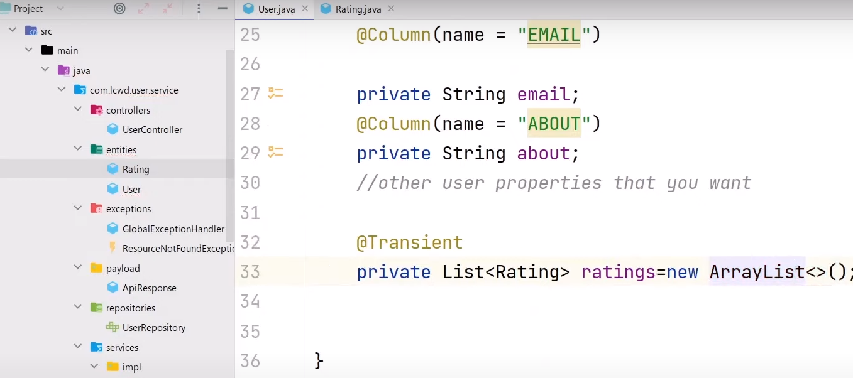

**Hotel Service**

**Below is hotel service implementation. Where there is HotelRepository, Entity and postgres database has been used for database operation.**

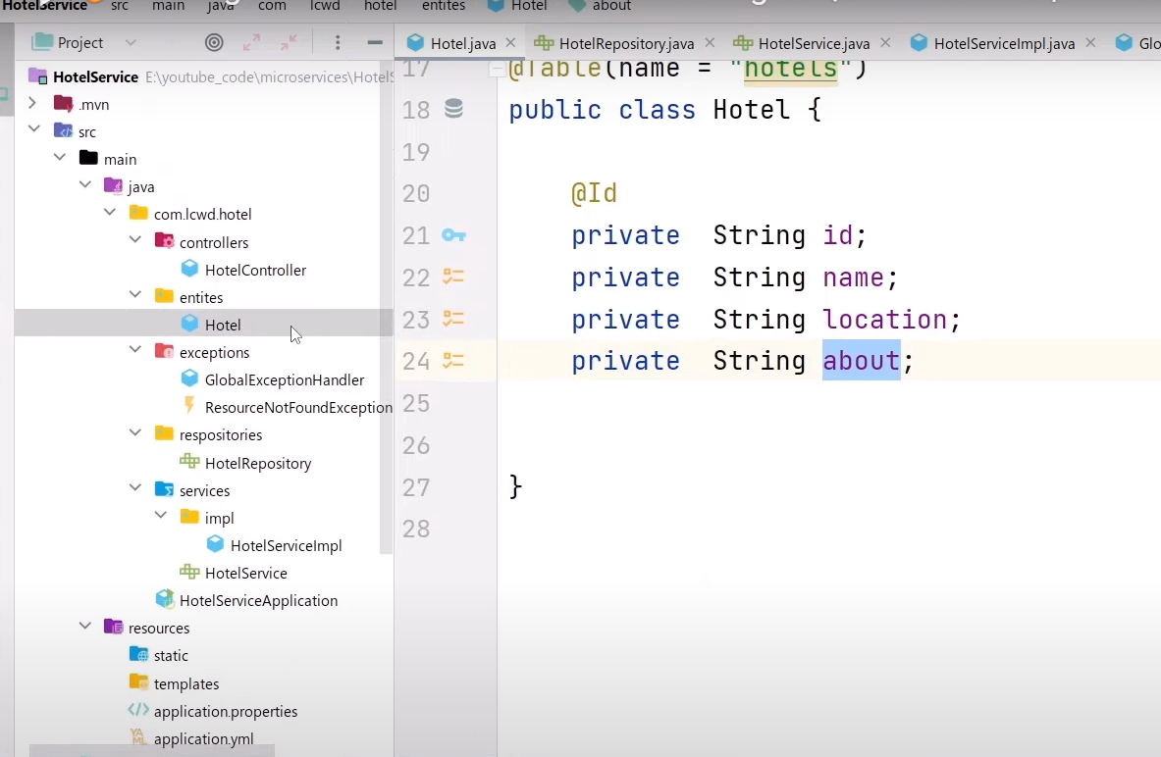

**Rating Service**

**Here we will use MongoDB**

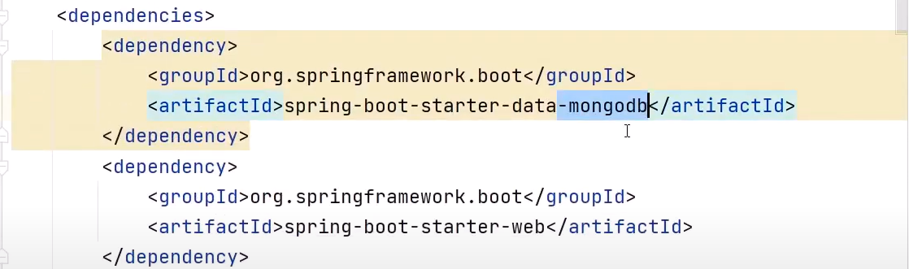

**We use @Document instead of @Entity to create table in mongoDB**

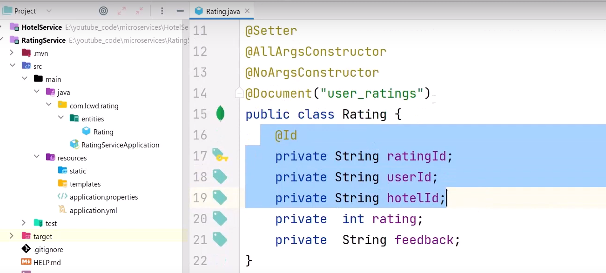

**Instead of JPARepository we use MongoRepository**

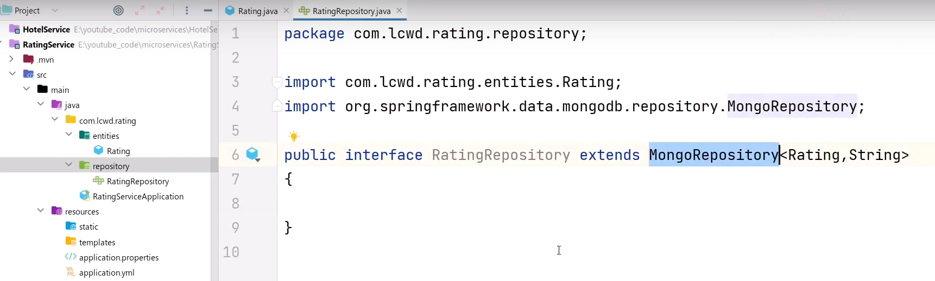

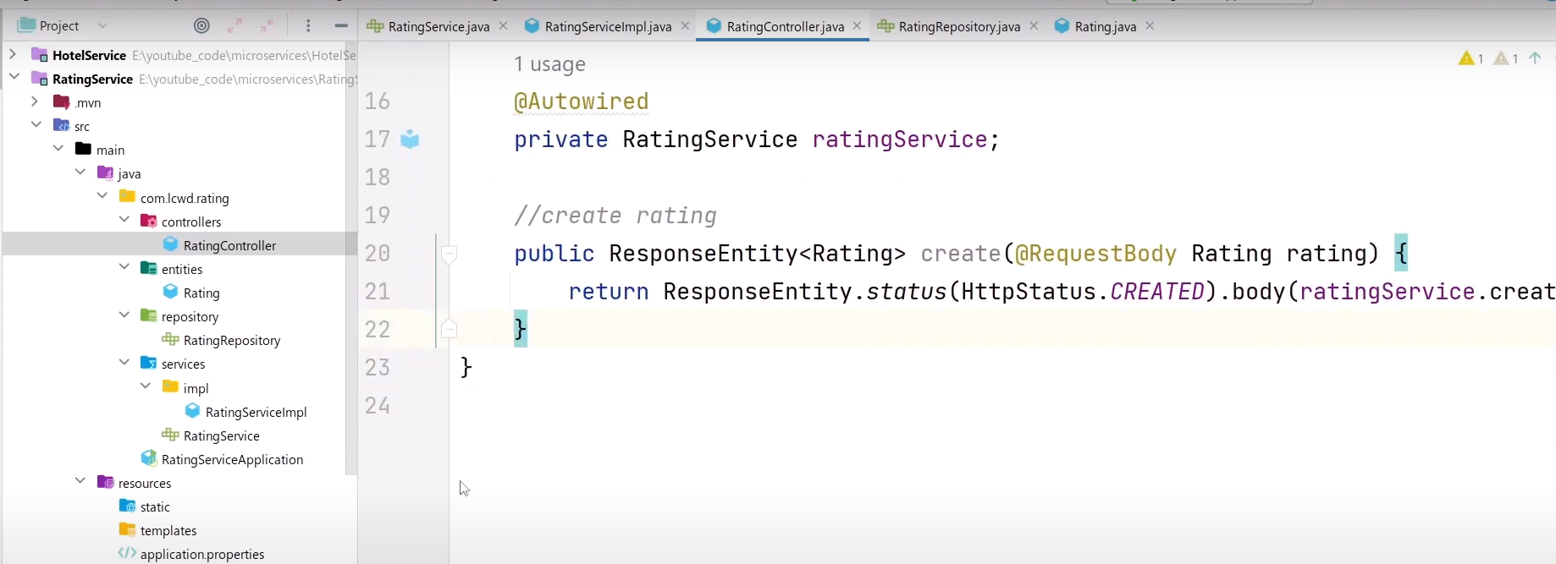

**Registry Service or Registry discovery**

**No need to give different address to call user service or Rating service or Hotel Service. Can be done this by using one address by service registry. It track all the information of each service like service is down or up etc.**

